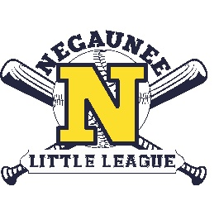
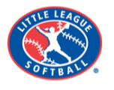
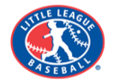

February 1, 2026

Dear Valued Community Partner,
Our 2026 Negaunee Little League (NLL) season is fast approaching and we are seeking your support. NLL is dedicated to providing community baseball and softball to over 400 Negaunee youth. As an all-volunteer, non-profit organization, sponsorships enable NLL to provide uniforms, equipment, excellent pre-season training opportunities for players and coaches, assist with player registration fees and maintain fields and facilities. Sponsors receive varying levels of recognition, depending on the sponsorship. NLL is a 501c (3) allowing for a tax-deductible donation.
Participating in the sponsorship of Negaunee Little League offers a valuable opportunity for local businesses and community organizations to enhance their visibility and engage with the community while supporting youth sports. Whether establishing a new partnership or renewing an existing one, sponsors contribute significantly to the success and sustainability of youth sports programs, fostering a positive environment for young athletes to develop their skills and enjoy the game.
In order for our teams to have their uniforms and for equipment to be purchased prior to the start of the season, and for signs to be ordered and hung, we are asking for your payment by April 1, 2026. For your convenience, we are offering a new payment option this year via Square. Links & QR Codes are included on the flyer. NLL still welcomes payment by check. We ask that you return the attached flyer to us via mail or to negauneelittleleague@gmail.com. Please send your logo graphic to negauneelittleleague@gmail.com.
One behalf of Negaunee Little League, we thank our existing partners for your continued support and welcome our new partners to a worthwhile, long-lasting relationship. Please reach out with any questions to negauneelittleleague@gmail.com.

Respectfully,
Joe Dost, 2025-2026 Negaunee Little League President

